**VMAT TRF(Treatment Delivery System) file analysis with RTplan DICOM(TPS)**

* Target Dose: 61.6Gy/28fx
* Total MU: 643.5
* Number of control points: 147
* Max. Gantry Speed (TPS): 6 deg/s
* Max. Dose Rate (720MU/min)
* Max. num of Arc: 1

Inspired by Park, J. M., they consider leaf speed, leaf acceleration, gantry speed and dose rate in QA metrics, found the MI_s, MI_a, MI_t had high correlation with gamma passing criteria results in VMAT plan. But the conventional QA metrics like MCS/LTMCS seems in-correlated with VMAT QA results.

**(Mateirals):**

* 20 NPC and 20 Prostate VMAT plans
* Eclipse System (two full arcs), dose grid 2.5mm
* MapCHECK2 (measured 2D dose distribution V.S. TPS calculated dose)

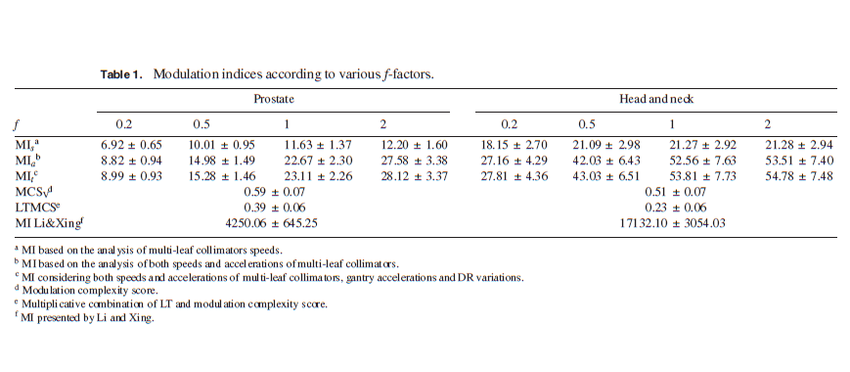

**We aim to use RTPlan DICOM to estimate the gantry speed, MLC speed, acceleration and dose rate during the delivery. But the difference between PLAN DICOM and TRF indicates the estimate for MLC speed, gantry speed is far away from the reality.**

1. **Check the consistency of differential MU between TPS and TDS**

1. **Check time interval between control points (estimated from DICOM VS. Delivery).**

1. **Check average gantry speed between control points (estimated from time interval). Though gantry speed exists negative, the dose rate is 0 in this gantry position. So it won’t influence the final delivery dose.**

1. **Check average dose rate between control points (estimated from time interval)**



1. **Check MLC speed between 2 control points (from TRF e.g. CP3-> CP4)**

**Reference**

**[1]** Park, J. M., Park, S. Y., Kim, H., Kim, J. H., Carlson, J., & Ye, S. J. (2014). Modulation indices for volumetric modulated arc therapy. *Physics in Medicine & Biology*, *59*(23), 7315.

**Next Plan**

1. **To ensure the current MATLAB code compatible to 2,3,4 Arcs in Monaco TPS (MoreThan2Arcs)**
2. **Variation of Time interval, Leaf Speed, Acceleration, Gantry Speed, Acceleration between TPS and TDS should be further researched (TRF_LOG_Analysis) -> dig the Integrity sequencer algorithm and integrity.**
3. **Unity fraction plan QA metrics statistics e.g. ATP for three sites CAMSUnity, SYSUCCUnity, SDUnity. (Elekta-Unity/QA metrics)** 
   1. **E.g. Plan complexity increase, delivery time increase, Total MU increase; QA quality decrease**
   2. **E.g. QA metrics like plan irregularity, plan modulation, aperture area * MU ……**
   3. **E.g. Develop an independent tool for online adaptive plan QA results evaluation and prediction.**

**Salesforce Issues (*Unity monaco 5.40 increasing complexity of adapted plans)***

1. **Unity Virtual Leaf concept in SSO**

**Experiment Design for current VMAT project**

**Experiment Design for current Unity DATA:**

**DATA preparation (2 weeks)**

* + **CAMSUnity ~ 14 cases (ATP plans, MR structures)**
  + **SYSUCCUnity ~24 cases (ATP plans, MR structures)**
  + **SDUnity ~23 cases (ATP plans, MR structures)**

**Task 1 (2 months)**

**do statistics for all the adaptive plan and compared them with reference plans including metrics like total MU, total number of segments, plan modulation, plan irregularities, aperture area*MU, estimated delivery time….**

**Aim:**

**1. to visually display or evaluate the plan complexity difference or trend within inter-fractions.**

**2. develop a small tool or merge them to current VMAT tools**

**Task 2 (3 months)**

* **Extract the patient geometry feature between fractions, like OVH, tumor-to-oar distance, and correlate them with plan complexity indices.**
* **Extract the patient geometry feature between fractions, like OVH, tumor-to-oar distance, and correlate them with plan dose.**
* **Extract inter-fractional setup shift or iso-shift and correlate them with the plan complexity indices difference.**
* **Extract DVH curves in each fractions and correlate them with plan complexity indices to see if there is any relationship.**

**Aim:**

1. **Predict the accumulated dose based on the geometry information**
2. **Predict the practical plan complexity change in future fractions**

**Task 3 (optional)**

**Explore the sequencing parameters in ATP and the correlation with final segment number and total MU**